LANDIS-II Widgets v1.0

User Guide

Lesley Bross

Robert M. Scheller

Portland State University

Last Revised: August 6, 2014

# Table of Contents

1 Introduction 2

1.1 Pre-requisites 2

1.2 Installation 2

1.3 Major Releases 2

1.3.1 Version 1.0 2

1.4 Acknowledgments 2

2 Launcher 3

2.1 Accessing the Launcher 3

2.2 Running the Launcher 3

2.3 Running the Replicator 4

# Introduction

This document describes how to install and use the Widgets UI with LANDIS-II. There are two Widgets in this release: the Launcher and the Replicator.

## Pre-requisites

The Widgets UI requires that LANDIS-II be installed on a computer. If LANDIS-II is upgraded or re-installed, the Widgets UI should be re-installed. LANDIS-II Widgets runs on Windows XP or later.

## Installation

The installer for LANDIS-II Widgets is available on the LANDIS-II website on the Extensions tab. You must have Administrator privileges on your computer to install LANDIS-II Widgets. The installer installs both menu items and desktop shortcuts for the Widgets.

## Major Releases

### Version 1.0

The initial release of LANDIS-II Widgets compatible with LANDIS-II v 6.0.

## Acknowledgments

Funding for the development of LANDIS-II Widgets version 1.0 was supplied by Google as part of the Google Summer of Code 2014. <https://www.google-melange.com/gsoc/homepage/google/gsoc2014>

# Launcher

The Launcher allows you to run a single scenario by selecting the scenario text file.

## Accessing the Launcher

The Launcher can be started from the desktop Landis-II Launcher shortcut: .

The Launcher can also be started from the Windows Start Menu: Start > LANDIS-II > v6 > Widgets > Landis-II Launcher.

## Running the Launcher

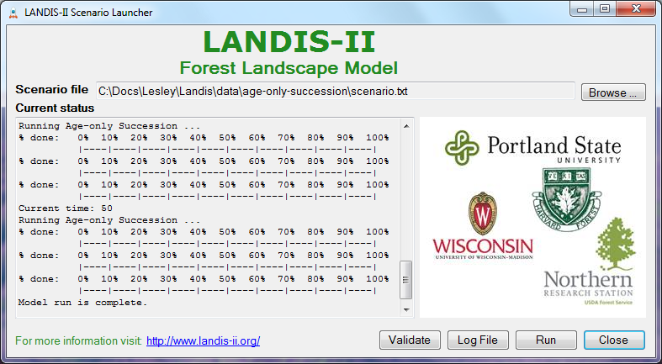

1. Use the Browse… button to locate the scenario text file you wish to run. This text file must comply with the general format requirements described in section 3.1 *Text Input Files* in the *LANDIS‑II Model User Guide*.
2. Use the Validate button to perform an initial validation of the scenario file. Note: You are not required to validate a scenario before running it.
3. Use the Run button to run the scenario. The current status of scenario processing will display in the Current status textbox. If an error occurs, the text color will change to red and the error log will be displayed in a separate window.
4. Click on the Log File button to view the log file after a scenario has run.
5. The following files will be generated by a scenario run: Landis-log.txt and errorLog.txt (if an error occurs). These file will be located in the Working Directory which is defined as the directory that contains the scenario file you selected.

# Replicator

## Accessing the Replicator

The Replicator provides advanced capabilities allowing you to select one or more scenario files a specified number of times.